Operations Dashboard Improvements 4 Deployment Guide

Revision History
Author | Revision Number | Date
isv | 1.0 | 08/27/2013

Deployment Instructions 3
1. Organization of Submission 3
2. Application Setup 3
2.1 Ant .Properties File 4
2.2 Build Scripts Setup 4
3. Database Setup 4
4. Deployment Instructions 5
5. Starting 5
6. Verification 5

Deployment Instructions

Organization of Submission

The content of submission follows directory structure provided below:

db_scripts

Contains the SQL statements for updated database table data and queries to be updated in Production environment via Query Tool in order to meet the needs of this assembly.

direct

Contains the sources for TopCoder Direct application added/updated in the course of this assembly. This directory replicates the application development distribution structure and includes only updated and new files.

docs

Contains this document which is the Deployment Guide for the Operations Dashboard Improvements 4 assembly.

test_files

Contains the SQL scripts with sample test data to be used for review purposes only.

Application Setup

The application is expected to be deployed to the following environment:

TopCoder Direct application

JRE 1.5
JBoss 4.2.3.GA
Informix DS 11.0

The submission has been developed against following SVN revision:

URL: https://coder.topcoder.com/tcs/clients/cronos/applications/direct/trunk
Repository Root: https://coder.topcoder.com/tcs
Repository UUID: fb370eea-3af6-4597-97f7-f7400a59c12a
Revision: 232673
Node Kind: directory
Schedule: normal
Last Changed Author: mashannon168
Last Changed Rev: 232654
Last Changed Date: 2013-08-21 21:14:14 -0400 (Wed, 21 Aug 2013)

The updates to the components have been made against following SVN revisions:

Contest Service Facade

URL: https://coder.topcoder.com/tcs/clients/cronos/components/contest_service_facade/branches/cockpit_trunk
Repository Root: https://coder.topcoder.com/tcs
Repository UUID: fb370eea-3af6-4597-97f7-f7400a59c12a
Revision: 232673
Node Kind: directory
Schedule: normal
Last Changed Author: mashannon168
Last Changed Rev: 229384
Last Changed Date: 2013-06-03 17:46:53 -0400 (Mon, 03 Jun 2013)

The database initialization scripts have been updated based on the following SVN revision.

URL: https://coder.topcoder.com/internal/database/scripts/trunk
Repository Root: https://coder.topcoder.com/internal
Repository UUID: cb5b18d2-80dd-4a81-9b1c-945e1ee644f9
Revision: 83764
Node Kind: directory
Schedule: normal
Last Changed Author: mashannon168
Last Changed Rev: 83763
Last Changed Date: 2013-08-21 15:16:28 -0400 (Wed, 21 Aug 2013)

Ant .Properties File
No new configuration properties have been defined in this assembly

Property Name | File property is stored | Example Setting

Build Scripts Setup

The build script for TopCoder Direct application (build.xml) provides the following targets which are to be used:

- deploy – builds and deploys the TopCoder Direct application to target server.
- deploy-apache-static – copies static web resources to .Apache HTTP server
- dist-backend - rebuilds the binary JARs for all components used by the application

The build script for Contest Service Facade application (build.xml) provides the following targets which are to be used:

- dist-tcs - rebuilds the binary JAR for component

Database Setup

Follow the instructions from TopCoder Databases Deployment Guide document from http://www.topcoder.com/wiki/display/docs/TopCoder+Databases+Setup+Guide for setting up the database.

Run test_files/db_update.sql script against target database to alter the database to meet the needs of reviewing this assembly.

Run test_files/test-data.sql script in order to populate the database with details for several sample contests and projects for testing/review purposes only.

Update newly added direct_project_active_contest_stats and other existing queries in Query Tool as follows (for details on Query Tool usage see http://www.topcoder.com/wiki/display/docs/TopCoder+Studio+Query+Tool+Usage ):

- Select TCS Catalog database
- Click Query List link on the left
- Locate direct_project_active_contest_stats query and update it's content (see db_scripts/tcs_catalog/query_tool/query_direct_project_active_contest_stats.txt for content of the query)
- Click Query List link on the left
- Locate direct_my_pm_projects_contests_v3 query and update it's content (see db_scripts/tcs_catalog/query_tool/ query_direct_my_pm_projects_contests_v3 for content of the query)

Deployment Instructions

This section provides the instructions for integrating and deploying the changes from Operations Dashboard Improvements 4 assembly in Production environment.

TC Direct Application:

- Copy files under direct directory from submission to dev distribution for TopCoder Direct application
- Re-build the binary JAR for Contest Service Facade component using ant dist-tcs command
- Build and deploy TopCoder Direct application using ant deploy command
- Copy static files to /mnt/apache/tcdocs directory using ant deploy-apache-static command.

If necessary consult following online documentation for details on building and deployment of TopCoder Direct application:

http://apps.topcoder.com/wiki/display/docs/TC+Direct+Setup+Guide

Starting

- Build and deploy the TopCoder Direct application
- Start JBoss server instance hosting TopCoder Direct application

Verification

Login to TC Direct application using URL like http://cockpit.cloud.topcoder.com/direct/ as user belonging to TC Staff group (heffan, for instance)
  - The Active Contests page must be displayed. The Dashboard button at the top left corner must be turned into drop-down list with three items.

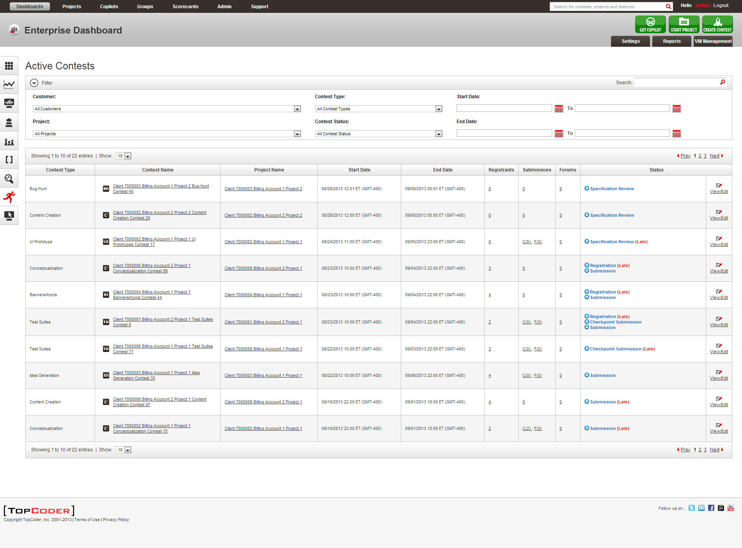

Select Operations Dashboard item from Dashboard drop-down menu at the top-left corner
  - The Operations Dashboard page must be displayed. The page must display the drop-down for selecting desired copilot in Filter area. Also the table listing the found projects must display the Active Contests column. Also the Platofrm Specialists drop-down in Filter area now must allow selecting multiple items. Also the Status column must now display the amount of delay for late phases and contest launches.

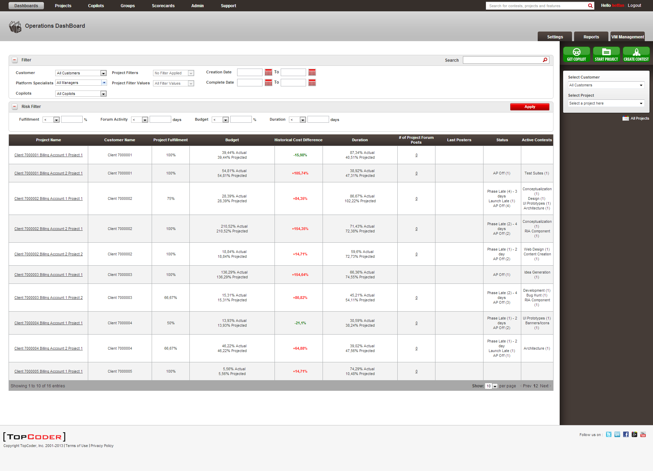

Select desired copilot from the Copilots drop-down
  - The projects table now must list only projects which have contests with selected copilot.

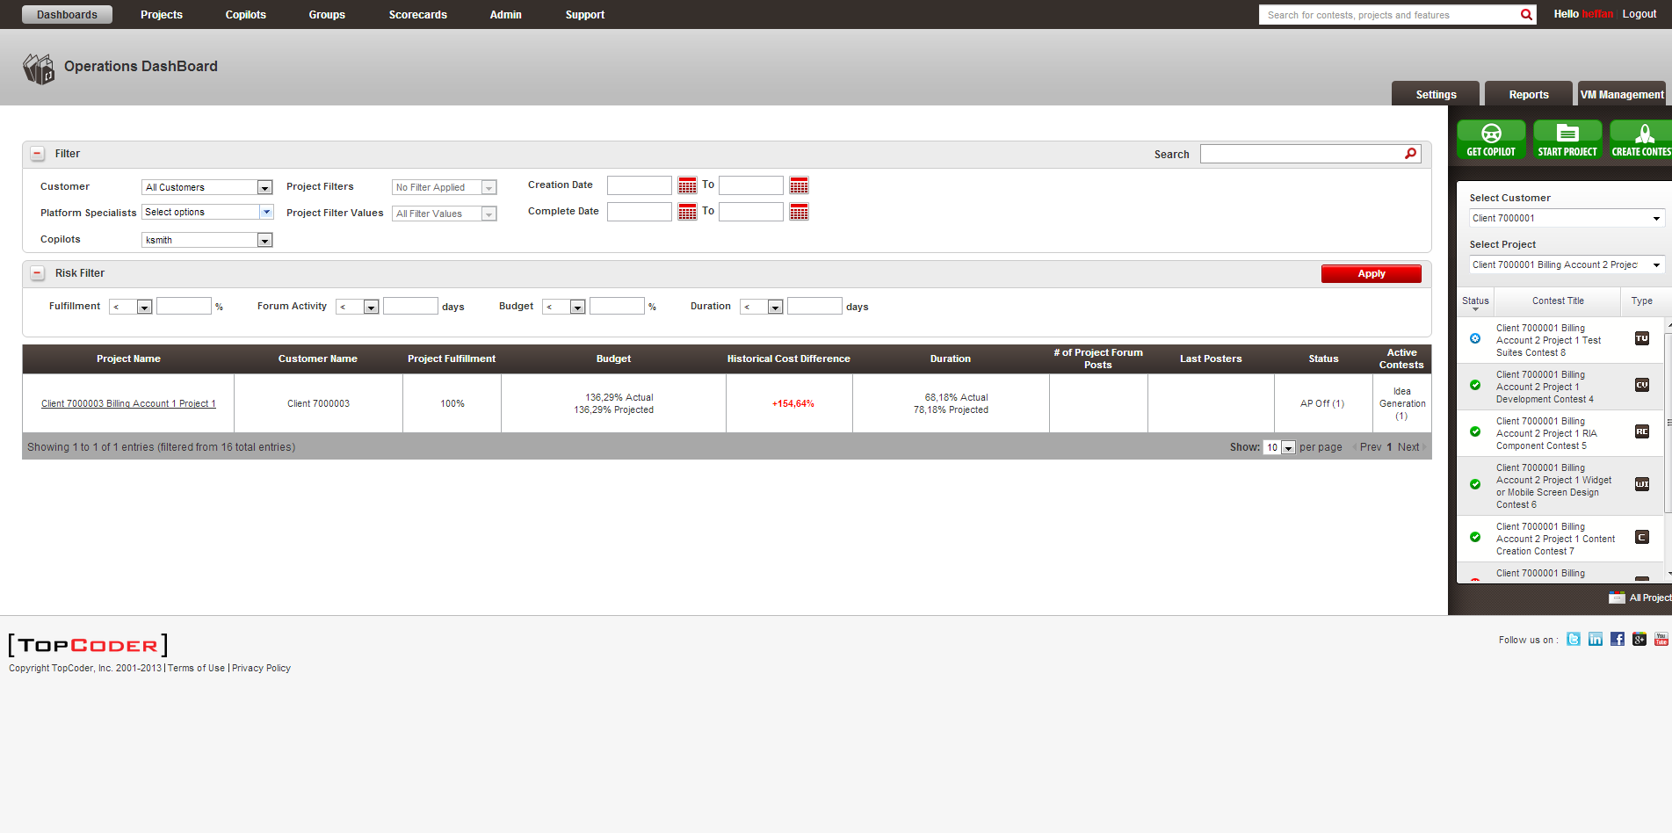

Select desired platform specialists from the Platform Specialists drop-down
  - The projects table now must list only projects managed by selected platform specialists.
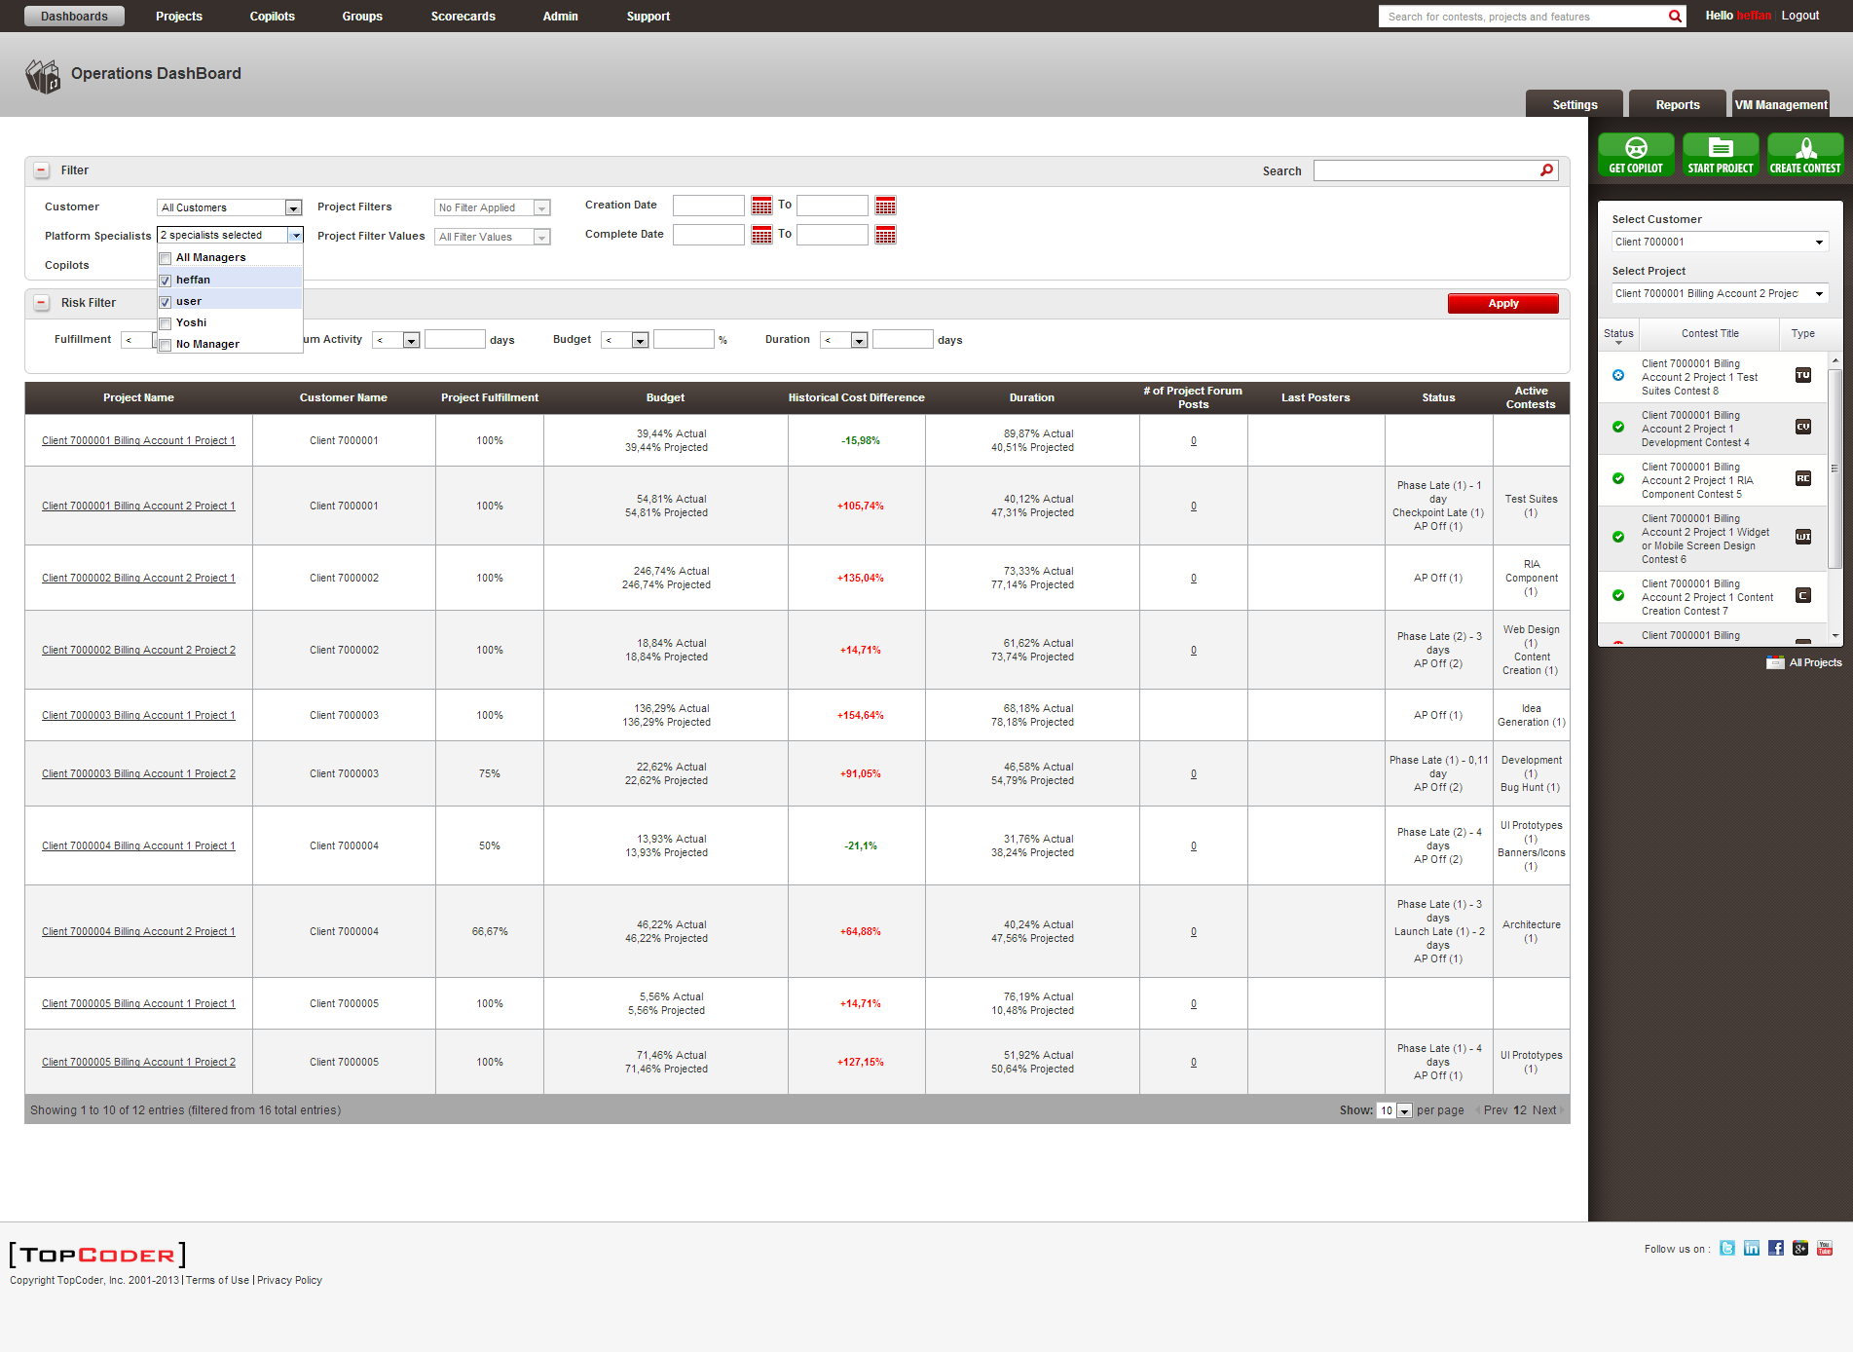

Click the header for Active Contests column in projects table
  - The projects must be sorted based on the number of active contests reflected by that column.

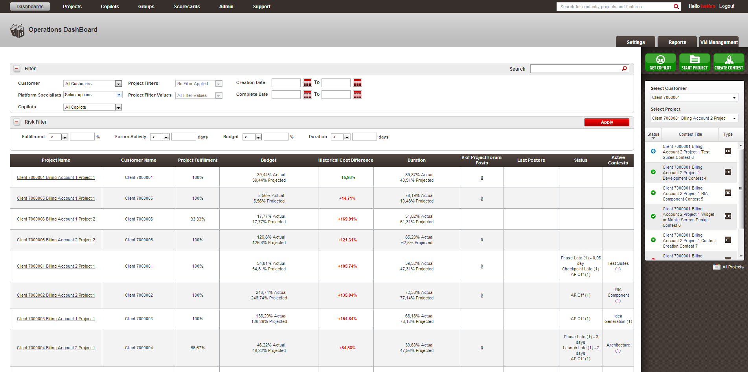

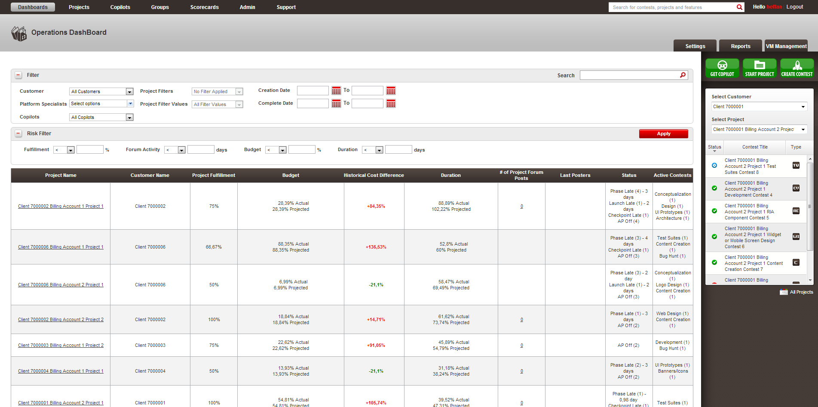
Resource Contact List

Name | Resource Email
isv

